Operational Rules for Artificial Sand Dressed Pitch October 2020
Covid 19
Each of your clubs will have spent a considerable time creating a risk assessment prior to your first session at Gordano Sports Centre. This risk assessment will have taken into account regulations that both the Government and National Governing Bodies for your specific sport have drawn up to keep players safe during your sports session. If you would like to see a copy of your clubs Covid risk assessment, please contact your clubs Covid Officer.
General Covid Guidelines for all clubs
- Please do not come to the Sports Centre facilities, including outdoor facilities if you, or anyone in your household, are feeling unwell, or have recently had any symptoms of COVID-19, as per government guidelines. Follow government guidance on how to get a test and self-isolate.
- During your visit to us, we ask that you continue to respect all staff and other customers, adhere to social distancing guidelines
- Face coverings should be worn inside all of our indoor facilities.
- Spectators are not currently permitted
- Toilet facilities are available in the New Sports Hall
- Changing rooms and shower facilities are currently unavailable and we ask that players come changed ready to play.
- Clubs should bring their own sanitisation products for their players to use.
- First aid – where it is possible, first aid should be self-administered. All clubs should ensure that they bring a well-stocked first aid kit to all booked sessions. In the event of an emergency, please contact reception on 07810 810350. There is a defibrillator situated in the reception of the New Sports Centre.
- All first aid incidents must be reported to reception.
- “Track and Trace” procedures have been put in place by your club, and should you develop any symptoms you must inform your club organiser / Covid officer immediately. Additional NHS QR Code Scan points are available in the shelter area.
- GSCT also have in place an alert policy to inform all club booking organisers of any occurrence in line with Government guidelines.
Entrance to the pitch
- Entrance to the pitch should only take place when the previous session players have departed the playing surface.
- Entrance will be through the single gate, into the pitch side shelter and then onto the playing surface.
- Exit will be through the double maintenance gates into the coach car park area. This is to ensure social distancing is maintained.
- When entering the pitch players should use the shoe cleaning brushes which are positioned in the shelter to ensure that all mud has been removed from the soles of the footwear before using the pitch.
- Additional wipe mats are positioned as you step down onto the pitch for one further clean.
Session Timings
- In order to assist both the club who have just used the pitch, and the new arriving players, clubs are asked to ensure they finish their session in sufficient time to ensure all players can collect any personal belongings and that coaches can gather up all sports equipment used within their own playing time. Only when the previous club have departed the pitch should the new club enter the facility.

Footwear
- GSCT Footwear policy must be adhered to by all users. GSCT staff will carry out regular inspections and ask any individual who is wearing incorrect footwear to leave the pitch.
- Due to the shorter pile length on a sand dressed artificial pitch this makes football and rugby studded footwear unsuitable. Wearing them increases the risk of turning over on your ankle, additional stress on your knees and will also significantly reduce the lifetime of the pitch surface. Wearing a flat soled trainer will compress the carpet pile, and provide insufficient grip for the player, therefore increasing the risk of injury.

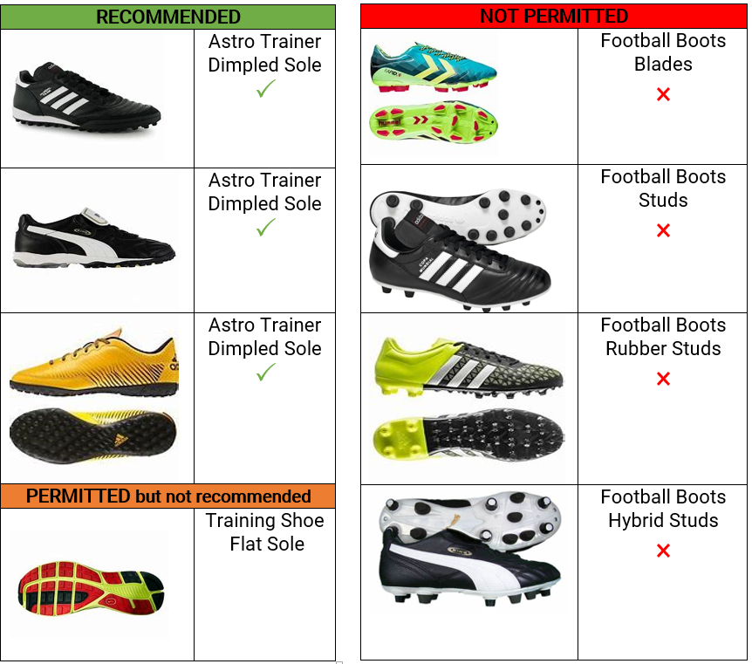

Equipment & Lighting
- All Goal posts should be set up by GSCT staff prior to or at the start of your session. Therefore please email your goal set up requirements in advance to sportcentre@gordanosportscentre.org.uk
- If you require the dividing nets in place for your session, please email sportcentre@gordanosportscentre.org.uk
- Floodlights will be programmed in advance to meet the needs of your booking and when exiting the pitch. Please leave the pitch promptly to allow staff to lock facilities at the end of day.
- GSCT will not be providing any sports equipment for hire such as bibs & footballs.
- Clubs should ensure that they adhere to their own risk assessment for the cleaning of sports equipment in line with regulations outlined by their National Governing Body.

Wheelchair access
- Clubs should inform the Sports centre manager of any requirements for assistance for entering or exiting the pitch. There is a wheelchair ramp available from reception

- Food and Drink
- No eating, chewing gum or fizzy drinks are allowed on the playing surface.
- All rubbish should be disposed of in the pitch side rubbish bins, or in bins provided in the shelter. Please take care ensuring that items which are recyclable are placed in the correct rubbish bin.
- No alcohol is to be consumed on the premises
Smoking
- Smoking, including vaping is not permitted anywhere on Gordano School premises.
Dogs
- No dogs, except guide dogs are allowed on Gordano School facilities

